**CB.EN.U4CYS21014**

**DEEPTHI J**

*UID MINI PROJECT*

Pharma Supply Chain Management (PSCM)

* Supply chain management in the pharmaceutical industry can renovate the organization to make **better use of assets and resources, engender profits, boost shareholder value, and optimistically respond to customer demand.**
* It can also facilitate:

a) Quicker customer response and fulfilment rates

b) shorter lead time

c) Greater productivity and lower costs

d) Reduced inventory supply throughout the chain

e) Improved forecasting precision

f) Fewer suppliers and shorter planning cycles

USER ANALYSIS:

Stakeholders of the Pharmaceutical Supply Chain include:

1. Multiple government agencies,
2. Hospitals
3. Clinics
4. Drug manufacturers
5. Drug distributors
6. Pharmacy chains
7. Retailers
8. Research organizations
9. FDA
10. Insurance companies
11. Healthcare management organizations
12. GPOs and etc.

FEATURES/REQUIREMENTS OF THE WEBSITE:

* The **MANUFACTURER** webpage should have an update option that allows users to update the new supply and, if necessary, review any prior updates, Storage locations, and transport transparency.
* **RETAILERS** should see a record of their purchases, travel agency contacts, expiry date of stock, name, and count of medicines they own, and buyer details.
* The **USER** webpage ought to contain a search bar for looking up certain products, and it ought to provide all the data in an easily digestible tabular manner.
* All new updates made by manufacturers should have approved options on the **GOVERNMENT OFFICIALS'** webpage, and users and pharmaceuticals should be able to see their ID so they can trust the source.

DESIGN LAYOUT (front page):

Refer: <http://18743734-880920.renderforestsites.com/>



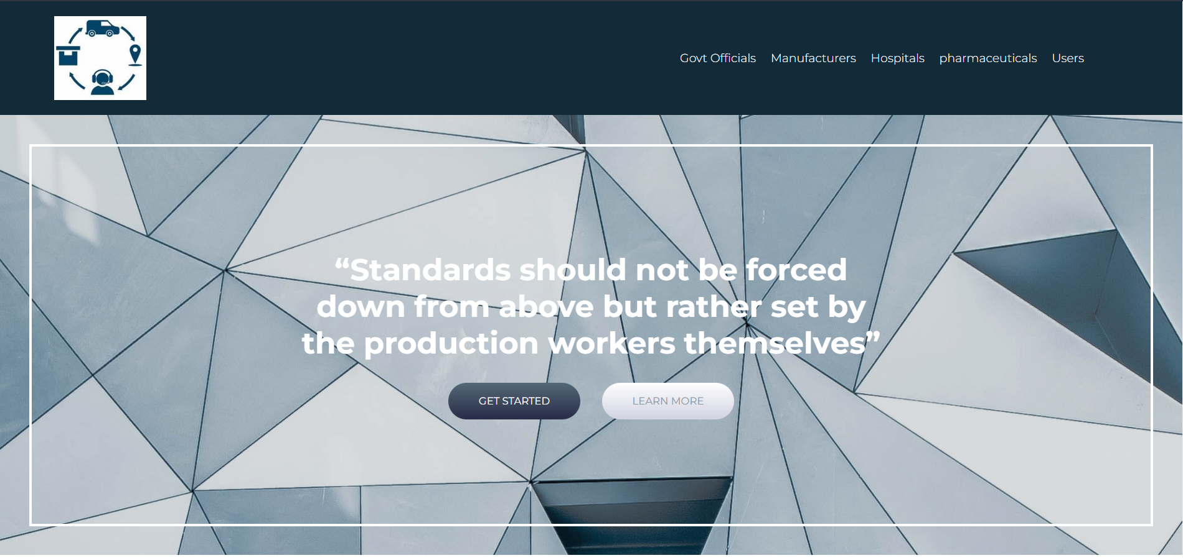



On the top-left:

1. Logo
2. Name of the supply chain.

On the top-right:

1. The relevant user can click the relevant option to sign in or to sign up.

**REQUIREMENTS**

***HOMEPAGE***

* Navigation bar
* News articles
* About us
* Documentation
* Team
* Features
* Clickers for authorization and certification links
* Chat list for customer help
* Login

***LOGIN/SIGN_UP***

Login as an end-user, as a distributor, or as a doctor or hospital, or Govt Officials

* For the end user, patient details (in brief):-
  + Name
  + Age or DOB
  + Diagnosis
  + Allergies (if any)
  + Consulting doctor
  + E-mails for news and other things
* For distributor, details (in brief):-
  + Corporate name and ID
  + Contact information
  + Location
  + GST number
  + License
  + **Upload documents (license, approval certification, equipment contract)**
* As a doctor, details (in brief): -
  + Registered ID from NMC
  + Location
  + Certificate from NMC
  + Contract with pharmacy (if available)
  + Previous quote date
  + Specialization
* As a pharmacy, details (in brief): -
  + Pharma UHID
  + Location
  + Certificate from “Whom (goodies [not candy])”
  + Approval from NMC
  + Drug license from CDSCO/ DCGI
* As a Govt Official, details (in brief): -
* Designation
* Govt ID
* The govt sector they work in
* Name
* DOB
* Certificated from govt
* As an insurer, details (in brief): -
* Email
* Password